**Pre-Class Quiz**

1. The pedigree below highlights a tasting disorder within a particular extended family. What is the pattern of inheritance for the inflicting allele? (The below questions are from p. 60 of Sinnott et al., 1958)

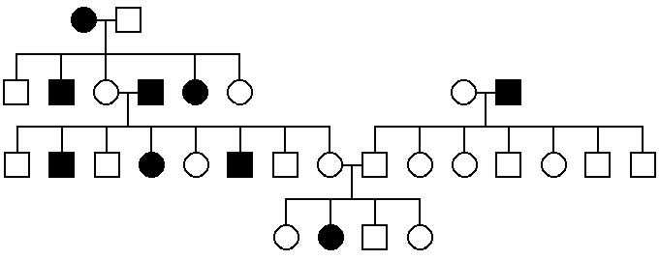

Answer: Autosomal recessive

This is the correct answer! Despite the high number of affected individuals, as well as the fact that there are affected individuals in every generational line, the parents of the last generation from the pedigree are not affected, but they do have an affected daughter. This immediately indicates that this is a recessive trait, because it can be masked in the parents but re-appear in their offspring. You can tell that this is not an X-linked recessive trait because the daughter has it, but her father does not. For the daughter to display an X-linked recessive trait, she must receive copies of the recessive allele from both her parents. Were this the case, the father would have the recessive allele on his X chromosome, and would display it, by default, because he only has one X chromosome. Thus, since the father of the affected daughter is not affected himself, you know that this is not an X-linked recessive trait.

2. The pedigree below is for a condition called polydactyly, which is having 6 fingers, within a particular extended family. What is the pattern of inheritance for the inflicting allele, and what is the probability that, if individuals A and B had another child, this child would be born with 6 fingers?

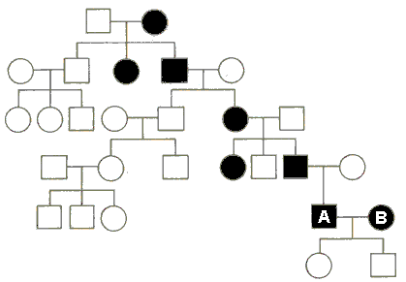

Answer: Autosomal dominant; ¾

This is the correct answer! You have correctly deduced that this is an autosomal dominant trait, presumably because there are numerous affected individuals and every affected child has an affected parent, but most importantly because individuals A and B do not have affected children. If this trait were recessive, the genotypes of individuals A and B would both have to be aa (or XaXa and XaY), and they could only have affected children because they both only have a alleles to give. However, since there are unaffected children, this MUST mean that the trait itself is dominant, but that parents A and B are heterozygous (Aa). This is the only way that both their children could avoid having the trait while both parents do.

Knowing that both parents are Aa, a simple monohybrid Punnet square identifies a 3:1 ratio of dominant to recessive probability for the next generation, i.e., 3/4 probability of having 6 fingers.

3. The pedigree below displays the occurence of a disorder called hemophilia, which is an inability to form blood clots, within a particular extended family. What is the pattern of inheritance for the hemophilia allele, and what is the probability that A and B's next child will have the disorder?

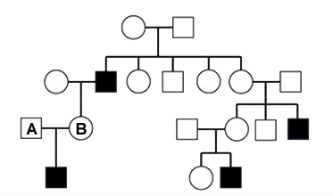

Answer: X-Linked recessive; ¼

This is the correct answer! You have correctly identified this pedigree as tracking a recessive allele, presumably because every affected individual in the pedigree does not have affected parents, which means that this can not possibly be a dominant trait. Also, you realized that this is an X-linked recessive, most likely because only males are affected (this is the only way to identify X-linkage from this pedigree, because technically this pedigree could actually represent an autosomal recessive trait, and so, from this, X-linkage is actually just a best guess; hemophilia IS X-linked in reality, though).

Since she has an affected son, individual B must therefore be heterozygous, which means she has a 1/2 probability of passing on her recessive hemophilia allele to all of her offspring. However, since individual A does not have hemophilia, and only has 1 X chromosome, this means he must have the dominant normal allele, and will pass this on to all of his daughters (his sons will get a Y). As a result, all of individual A's daughters will have the dominant normal allele, and will not be affected. Thus, the only way for a child to be affected is to be a son (1/2 of getting Y), and to receive the recessive X from mom (1/2). 1/2 X 1/2 = 1/4.

4. Which of the following observations support the idea that the gene controlling maleness is located on the Y chromosome?

a. XO individuals are usually sterile, normal intelligence, female, with slight physical abnormalities.

b. XXY individuals are sterile males with long limbs.

c. XXX individuals are normal females.

d. Some men are XX but have a small piece of the Y attached to another chromosome.

**e. All of the above are observations suggesting that the gene controlling maleness is on the Y chromosomes.**

5. White eyes is a recessive X-linked trait in fruit flies. If a white-eyed female fruit fly is mated to a red-eyed male, their offspring should be:

a. 50 percent red-eyed and 50 percent white-eyed for both sexes.

b. All white-eyed for both sexes.

**c. All white-eyed males and all red-eyed females.**

d. All white-eyed females and all red-eyed males.

e. 50 percent red-eyed males and 50 percent white-eyed males and all red-eyed females.